3 x tables

Lay out the answers to the x table on the floor.

Adult: Call out the times tables question

Child: Jump on the answer to the question

6 x tables

Tricky 6 patterns

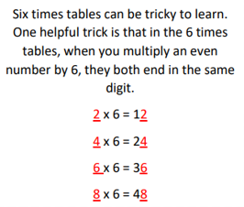

Try it for yourself.

3 x tables

Paper Plate practice wheel

Adult: Cut the edges of 1 paper plate to split it into 12 parts. Attach it to a 2nd plate using paper fasteners

Child: Label each section on the front plate

1 – 12.

Lift each flap and add the multiple

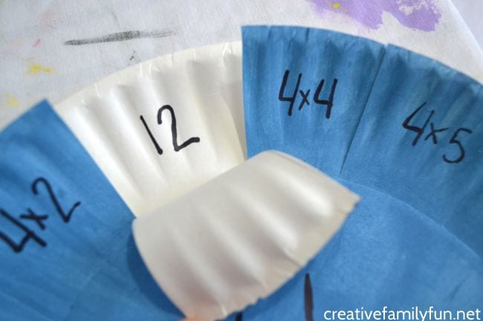

4 x tables

Add the multiples of 4 to a set of empty bottles.

Adult: Read a 4 x tables question

Child: Aim to hit down the answer with the ball. If you hit down an incorrect skittle – tell the adult what question would match the one you hit down.

4 x tables

Marching

March on the spot whilst counting in 4s – one step for each number.

Repeat doing squats, doing star jumps etc

7 x tables

**Scavenger Hunt**

Hide the answer to the times tables around the room/garden.

Adult: Read out the 7x table question

Child: Find the answer. It is somewhere in the room!

9 x tables

Nerf Guns

Record the answers to the times tables and space them out on the floor or wall.

Adult: ask the x tables question

Child: Use the nerf gun to shoot the correct answer

7 x tables

Fortune tellers

Create your own fortune tellers to help you to practice your 7x tables.

8 x tables

Fly swat

Place all of the answers on the floor/table.

Adult: Read out a question

Child: swat the answer as quick as you can.

This is much more fun with more than 1 player!

11 x tables

Pattern Spotting

Write out the 11 x table 1 row at a time

e.g. 1 x 11 = 11

2 x 11 = 22

3 x 11 = 33

Look at the first multiple and the product (answer). What pattern do you notice?

11 x tables

Play catch.

Every time you catch count on the next multiple of 11.

If you drop the ball or count the wrong multiple, start again from the beginning.

12 x tables

Bean bag throw

Stand in the middle with the 12 x tables answers all around you.

Adult: ask a 12x table question

Child: throw the beanbag on the answer.

Know all your x tables?

Rock, Paper, Scissors, Multiply.

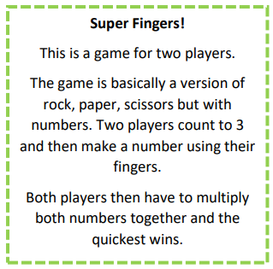

Know all your x tables?

Egg carton x tables.

Using an egg carton, write the numbers 1-12 in the bottom of each depression. Place two marbles inside the egg carton and close the lid. Shake the egg carton, open the top, and then add whichever two numbers the marbles have landed on.

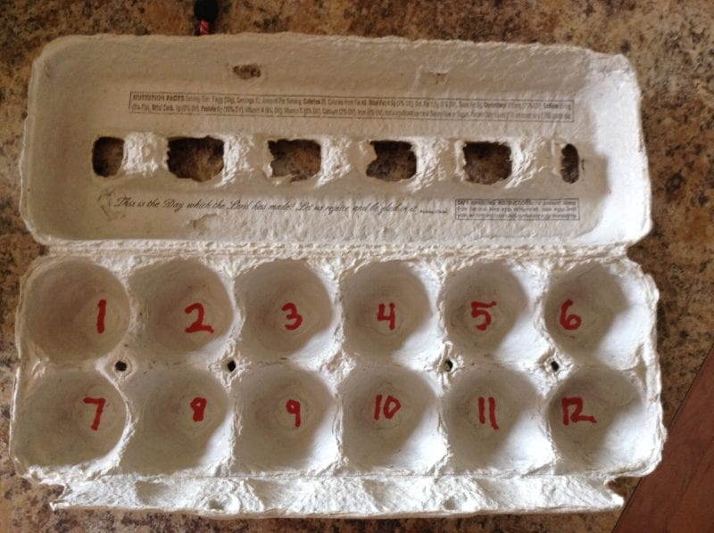

6 x tables

Matching Cards

Play in groups of 3/4

Share all the cards out equally between the players with one card down in the middle. Go around the group one at a time and take it in turn to put a matching card down. If you do not have a matching card you pick up a card from the bottom of the pile. The winner is the person at the end who has the least amount of cards.

Know all your x tables?

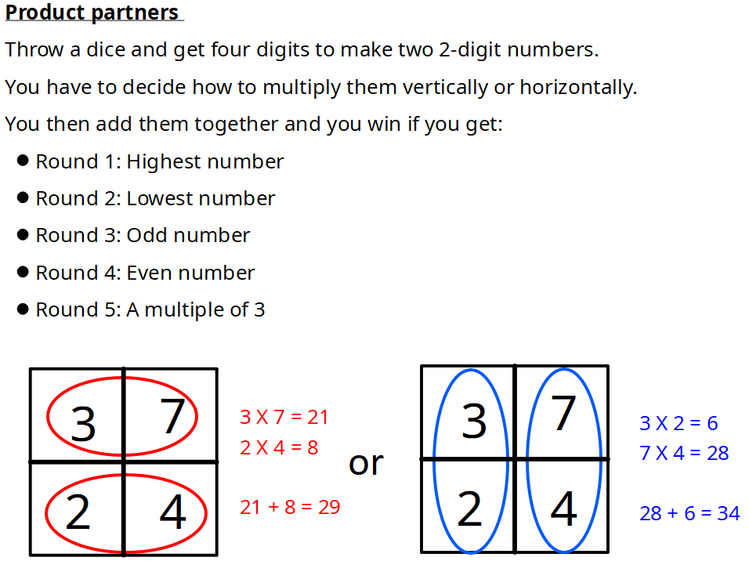

Know all your x tables?

**Pepperoni Pizza**

Play in pairs

Throw a dice to decide the amount of pizzas you need to get. e.g 6

Throw another dice to tell you how many pepperonis to put onto the pizza. e.g 3 (draw these on)

On a whiteboard write the calculation and the say the sentence.

e.g 6 x 3 =

6 lots of 3 equals 18 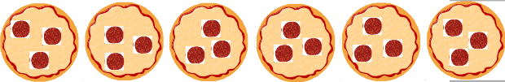

Know all your x tables?

**How close to 100?**

Play in pairs

Throw dice to get two numbers (4 and 6) that you can multiply together e.g. 4 x 6 = 24

You can then colour that in on a hundreds square (anywhere on the square) making an array to represent that number 24

e.g. 1 row of 24

2 rows of 12

3 rows of 8 etc

Your friend then does the same on the same square but in a different coloured pencil.

You keep on going until the whole square is full.

The person who has the most coloured squares wins.

6 x tables

**Track game**

Play in pairs - each have your own colour of counters.

e.g. player 1 = red counters player 2 = yellow counters

Pick a number to start from on the track.

Player 1 rolls the dice and for example lands on the number 6.

Player 1 must then look for the calculation in the middle that matched the number they have landed on. Player 1 can then put a counter on that number. Player 2 does the same. The winner is the one who has the most coloured counters at the end. 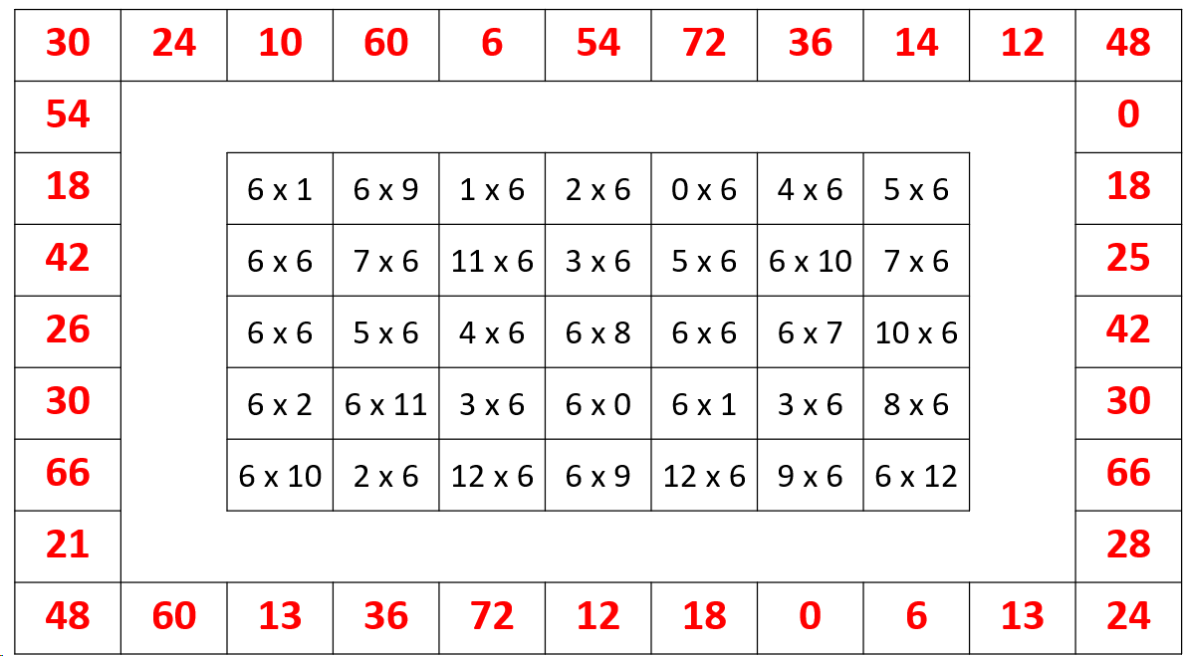

Know all your x tables? 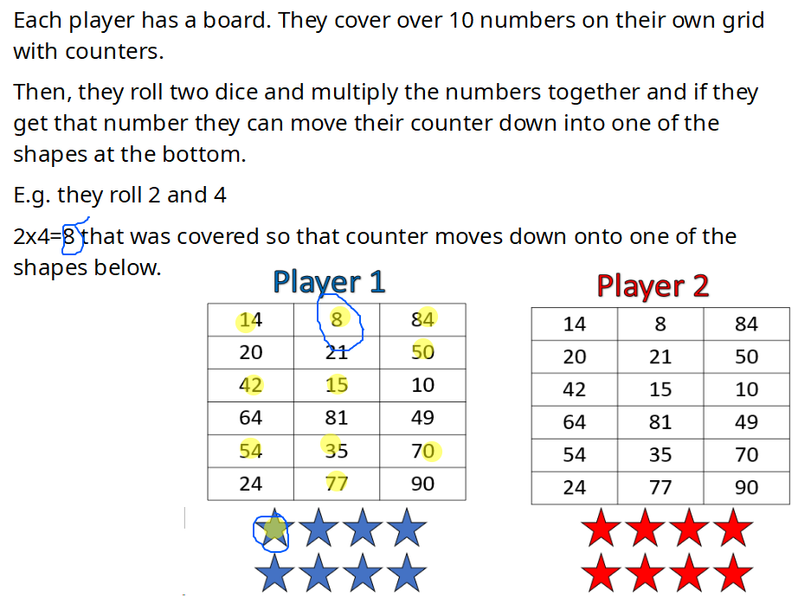

Know all your x tables?

**Gold to Gold**

One player starts at left other on right. They roll two dice and multiply together. If they see a product after their gold they can cover with a counter, then look for the next. They are trying to get the gold on the other side. They can focus on getting over or blocking each other to stop the other one to get to gold.

